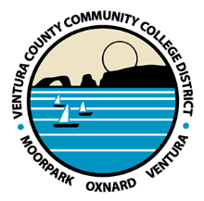
Ventura County Community College District
Chancellor’s Office

Patti Blair
FOR IMMEDIATE RELEASE pblair@vcccd.edu
(805) 652-5502

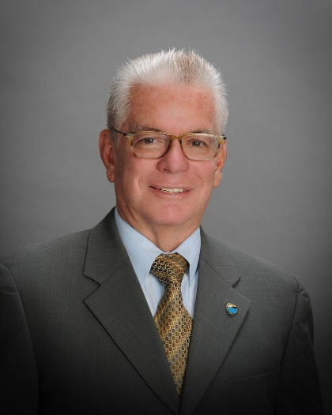 | 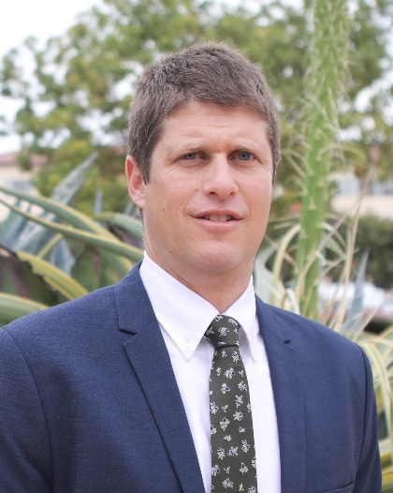
Bernardo M. Perez  Chair | Joshua Chancer  Vice Chair

VCCCD Board of Trustees names Chair and Vice Chair
Bernardo M. Perez to lead the board for third time

(CAMARILLO, Calif.) January 13, 2020 – The Ventura County Community College District Board of Trustees elected Bernardo M. Perez and Joshua Chancer as chair and vice chair, respectively, during the annual organizational meeting, Dec. 17.
Perez was selected by fellow trustees as the new chair of the five-member elected board, which also includes a VCCCD student board member. In 2010, Chair Perez joined the board of trustees. He served as chair in 2012 and 2016, and as vice chair in 2015.
Previously, Perez represented his community on the Moorpark City Council, including serving as mayor of the City of Moorpark. Perez worked as a project manager for the Cabrillo Economic Development Corporation in Ventura and was previously employed with the Los Angeles Department of Water and Power for more than 30 years.
Perez has served his community through a number of nonprofit organizations, including the Ventura County Civic Alliance, Clinicas del Camino Real, United Way of Ventura County, Cabrillo Economic Development Corporation and El Concilio del Condado de Ventura. He served on the Children’s Health Initiative Steering Committee, HOME Housing Task Force, Justice and Peace Commission, and worked with the Archdiocese of Los Angeles, Ventura County Living Wage Coalition (Co-Chair) and the 2010 Ventura County Housing Conference Planning Committee. Additionally, he assisted the Moorpark Unified School District as a classroom volunteer/reader.
Chancer joined the board of trustees in 2018. An environmental advocate, he was instrumental in the board of trustees’ Resolution in Support of Climate Change and Environmental Sustainability that was adopted April 2019. A resident of Ventura County for a majority of his life, he proudly attended public schools from grade school through his college and university career, including Ventura College in 1996.
Chancer has 20 years of experience in public education, teaching English language arts, social science and adult ESL. Currently he is employed by the Oxnard Union High School District as a social science teacher. Chancer has also been an adjunct instructor at California Lutheran University, Graduate School of Education.
He received a bachelor’s degree in social science from San Diego State University in 2001, a California teaching credential from CSUCI in 2002 and a master’s degree in education from National University. In 2001 he was recognized as a Governor’s Teacher Fellow, and in 2009 he was honored with the Pacific Teacher Innovation Network Award and Grant.
About Ventura County Community College District
The Ventura County Community College District is a member of the 115-campus California Community College system, and serves more than 32,000 students annually. The District’s three colleges--Moorpark, Oxnard, and Ventura--offer programs in general education for degrees and certificates, transfer to four-year colleges and universities, career technical education, and provide opportunities to engage in co-curricular campus activities. For more information, please visit vcccd.edu.

###

